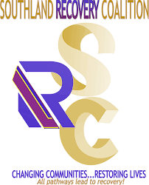 | SOUTHLAND RECOVERY COALITION  ROSC (Recovery Oriented Systems of Care)  &  Healing Center COGIC
Vendor Application: COMMUNITY RESOURCE FAIR
1351 Stanley Blvd, Calumet City, Illinois 60409 (Location -- Outside Parking Lot)
Saturday, June 12, 2021 | 10:00am – 1:00pm
Business Name
Contact Name |  | Mobile No.
E-mail Address
Website
Business Address
Business Phone No.
Nature of Services
Give-A-Ways

REGISTRATION DEADLINE: FRIDAY, JUNE 4, 2021 AT 5:00PM; E-mail registration form to retincgroup1@gmail.com. Vendors must provide their own equipment, including canopies, tables, chairs, advertising materials, fliers, etc. No electricity or running water is available for the purposes of your exhibit. Vendors must set up by 9:30am and break down by 1:30pm. Vendors are responsible for leaving the area in the same condition as they found it. Important Note: All services, give-a-ways or activities must be free of charge to participants. We reserve the right to censor any vendor & booth as applicable.
Terms & Conditions: I hereby agree and give my permission for SRC to record, film, photograph, and audiotape or videotape vendors and their activities (hereinafter collectively referred to as “Works”) and to display, publish or distribute these Works for the purpose of publishing, posting on the ROSC website and posting on social media sites. I hereby waive any right to approve the use of these Works now or in the future, whether the use is known to me or unknown, and I waive any right to any royalties related to the use of these Works. I understand that the Works may appear in electronic form on the internet or in other publications outside of the ROSC’s control. I agree that I will not hold ROSC responsible for any harm that may arise from such unauthorized reproduction.
Event Sponsors & SRC Partner Agencies: | Cornerstone Community Development Corporation, NFP (Lead & Fiscal Agency) • Indigenous Community  Service Center • Lights of Zion Institute • Reassemble Education & Training, Inc.
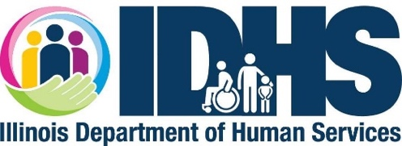
This project is supported in part by the Illinois Department of Human Services Division of Substance Use Prevention and Recovery,
as part of the Social Services Block Grant award from the Federal Administration for Children and Families (G-1801ILSOSR).

